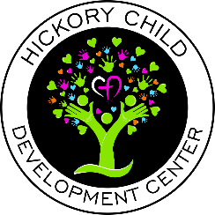
Annual Report 2020
Wow, I don‘t even know where to begin when talking about the last year. I would say three words come to mind “GOD is GOOD!” HCDC staff, parents and children are stronger than ever in our Faith! We learned to lean on God and allow him to steer the path HCDC was going to take. Has it been hard? Yes! Our director’s roles really changed, as we became mentors to staff, children and parents. We showed them God’s grace and understanding and they showed the same to us. From the beginning essential personnel children would be dropped off at 7 am and not see their essential parents for sometimes 48 hours. HCDC was the only stability the parents and children had.
During the pandemic HCDC was blessed with donations from the health department, local businesses, and our parents when it was impossible to find things. Due to the outpouring of love and generosity we decided we want to do more service for the local community. For Christmas, we adopted five foster families from Arrow Child and Family ministry. The beginning of March we held a food drive for the Harford Community Action Agency. We want to be known as the center that serves our local community. We want to show the children how to show God’s love at an early age.
HCDC did however take a large financial loss during COVID due to having lower class sizes for at least six months. We had to make many adjustments to our daily routines that also hurt us financially. We are also not allowed to combine rooms and cannot have teachers cover other classes as much as possible.
As we continue to move forward, we are extremely confident that God will remain faithful and keep HCDC strong.

